iConvNet Application

User Manual（Full Screen Device）

Copyright Information
iConvnet is a trademark or registered trademark of ICONVNET TECHNOLOGY PTE. LTD. (“iConvNet”) in Singapore and other countries and/or regions. Our company holds ownership rights only to its own trademarks and product names. Other trademarks and product names mentioned in this manual are the property of their respective owners.
The products described in this manual may include computer programs stored in memory or other media. Our company’s proprietary rights to such programs are protected by the laws of Singapore, other countries, and relevant international laws. The purchase of this product does not grant the purchaser any rights, express or implied, to such computer programs. Without prior written authorization from our company, no enterprise, organization, or individual may copy, modify, distribute, decompile, or reverse-engineer any computer program in any form.
Disclaimer
Every effort has been made to ensure the accuracy and completeness of the content in this manual; however, our company assumes no responsibility for any errors or omissions that may occur.
Due to ongoing technological developments, our company reserves the right to change product designs and specifications without prior notice. This manual may not be copied, modified, translated, or distributed in any form without prior written authorization from our company.
Third-party products and content mentioned in this manual are owned by their respective parties, and our company makes no guarantees regarding their accuracy, validity, timeliness, legality, or completeness.
For more information or suggestions regarding this manual, please visit our website at www.iconvnet.com or contact us by email at sales@iconvnet.com.

Content
Foreword 1
Reader 1
Agreement 1
Identifier Symbol Conventions 1
Software Interface Element Conventions 1
Revision history 1
1. Product Overview 2
2. Preparations Before Use 2
2.1 Connecting to the Network 2
2.1.1 Installing the SIM Card 2
2.1.2 Enable WLAN 3
3. Basic Operations 3
3.1 Registration 3
3.2 Login 3
3.2.1 Account and Password Login 3
3.2.2 Login Shortcut 4
3.2.3 Scan QR Code to Login 5
3.3 Homepage 5
3.4 Group 6
3.5 Messages 7
3.6 Work Module Collection 7
3.6.1 Contact 8
3.6.2 Locate Service 9
3.6.3 Calling 10
3.6.4 Video Return 10
3.6.5 Call Recording 11
3.6.6 Work Order 12
3.6.7 Patrol 13
3.6.8 Event Reporting 14
3.6.9 Safety Inspection 15
3.6.10 Video Surveillance 18
3.6.11 Watermark Camera 20
3.6.12 Gallery 20
3.7 Voice and Video 21
3.8 Settings​ 21
3.8.1 Basic Account Information 22
3.8.2 Audio/Video Settings 22
3.8.3 Voice​​ 23
3.8.5 Display 24
3.8.6 Functional settings 24
3.8.7 Bluetooth Devices 25
3.8.8 System Settings 25
3.8.8 Close Application and Log Out 26

Foreword
This document describes its intended audience, conventions, and revision history.
This document uses the S350 as an example to introduce the relevant functions and usage methods of the iConvNet APP in full-screen devices .

Reader
This document is primarily intended for the following personnel:
- Technical Support Engineer
- Marketing and Sales Engineer
- End users

Agreement

Identifier Symbol Conventions
symbol | significance

Software Interface Element Conventions
Format | significance
“” | This symbol represents the name of a software interface control, such as " Click OK " .
【】 | This symbol represents the name of a hardware interface control, for example: pressing the [ PTT ] key.
> | This symbol is used to guide users through multi-level menus. For example, selecting " New " under the " File " menu is represented as: " File > New " .

Revision history
Document Version | Product Version | release date | describe
00 | V3.1 | 2025-9​ | First release

1. Product Overview
iConvNet APP is a device multimedia trunking application software suitable for the field of multimedia converged communication in various industries. Devices with iConvNet APP installed can access the dispatch system through various network channels to realize trunking services such as voice calls, video calls, emergency calls, broadband data access, and video dispatching. It can be widely used in industries such as public safety, energy, and transportation to realize professional trunking dispatching and multimedia dispatching functions.
iConvNet APP supports multiple devices, including private network cluster devices and public network devices (Android system). Private network cluster devices with iConvNet APP installed can access private network communication; public network devices with iConvNet APP installed can access public network communication via WiFi/3G/4G/5G and other bearer networks.

2. Preparations Before Use

2.1 Connecting to the Network
iConvNet APP can only connect to the iConvNet server in a network environment to enable functions such as voice calls, video transmission, and sending and receiving text messages. The device supports the following networks:
- Mobile network
- WLAN
Please install a SIM card or connect to WLAN.

2.1.1 Installing the SIM Card
- Install a SIM card on the device so that the iConvNet APP can use the mobile network to connect to the Internet.
- When installing the SIM card, please ensure that the notch direction is consistent with the notch direction of the card slot.

2.1.2 Enable WLAN
iConvNet APP in a WLAN environment , please enable WLAN.
iConvNet APP in a WLAN environment can save data usage.

3. Basic Operations

3.1 Registration
Before using the device, you need to register an account on the management platform, as shown in Figure 3-1 below:
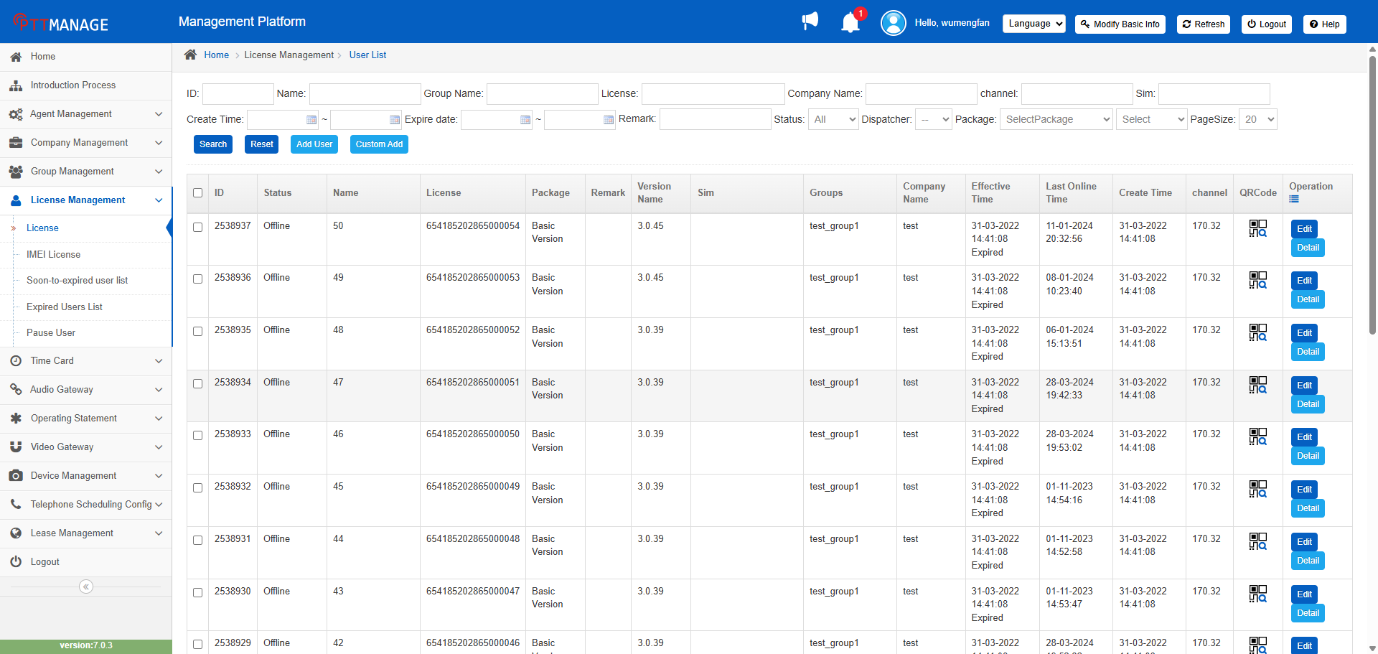
Figure 3-1 Account Registration

3.2 Login

3.2.1 Account and Password Login
After entering username and password on the login page, set the IP address of the corresponding server and click login, as shown in Figure 3-2 below:
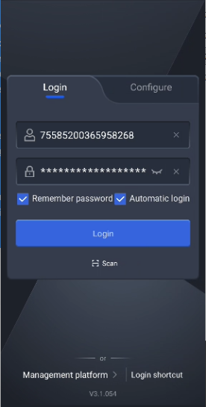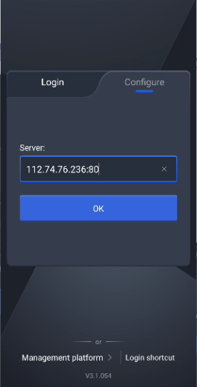
Figure 3-2 Account and password login

3.2.2 Login Shortcut
To use the login shortcut function, you need to register an account using your device IMEI number during the service period. Then, on the account login page, set the corresponding server IP and click Login shortcut button to log in to the corresponding account, as shown in Figure 3-3 below:
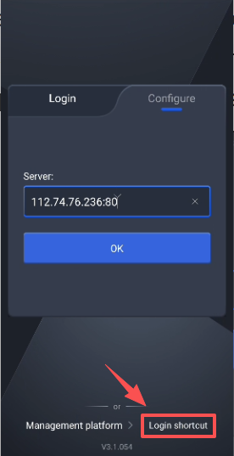
Figure 3-3 One-click login

3.2.3 Scan QR Code to Login
To log in using the QR code login function, you can scan the platform's account QR code, as shown in Figure 3-4 below:
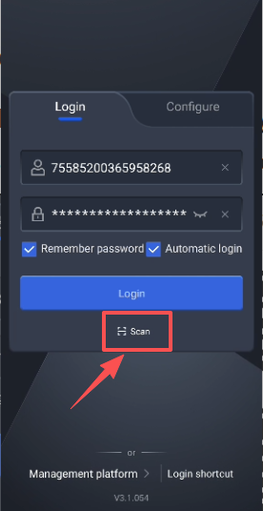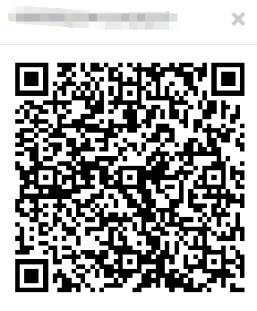
Figure 3-4 Scan QR code to login

3.3 Homepage
After successful login, you can access the homepage interface. Multiple entry points are gathered on the homepage, which also features a prominent, large voice button, as shown in Figure 3-5 below :
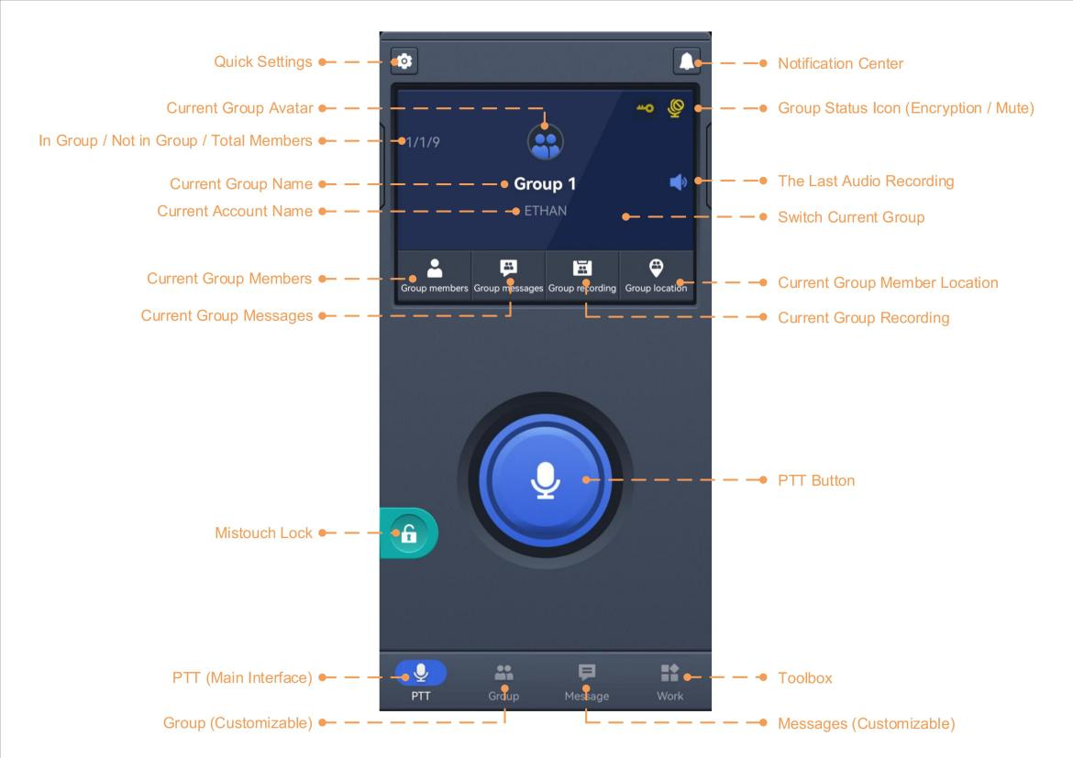
Figure 3-5 Homepage

3.4 Group
Click to switch to the group interface. You can quickly select a group, and click “”on a group to view its members, as shown in Figure 3-6 below:
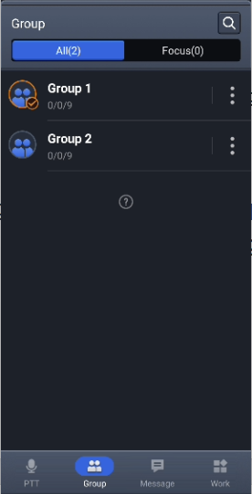
Figure 3-6 Homepage

The button allows for some group operations, including group messaging, call recording, and location services , as shown in Figure 3-7 below :
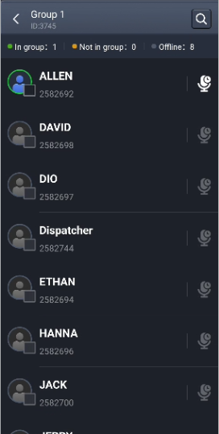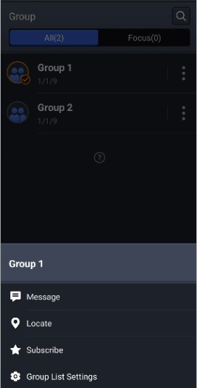
Figure 3-7 Group Function Page

3.5 Messages
Click to switch to the message interface. The message function page includes a chat list, search and create message buttons, etc. , and also displays dispatch center conversations and broadcast notifications , as shown in Figure 3-8 below:
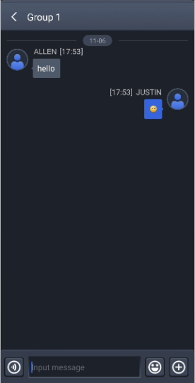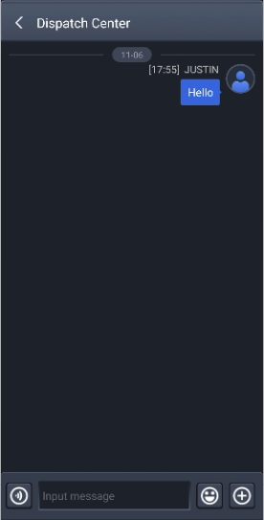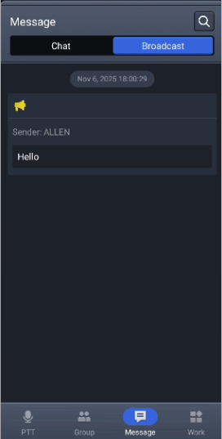
Figure 3-8 Messages function page

3.6 Work Module Collection
Click to switch to enter the work interface, which integrates various APP functions, making it easy to quickly select and operate the required function, as shown in Figure 3-9:
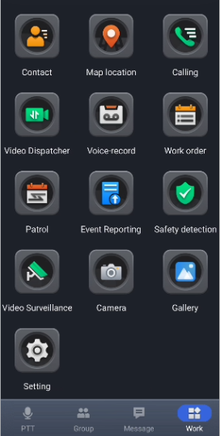
Figure 3-9 Function Page

3.6.1 Contact
The Contact feature allows users to view all users within a company and provides a search function. When a company has a large number of users, you can quickly search for target users. Users can also be added to follow for quick contact, as shown in Figure 3-10 below .
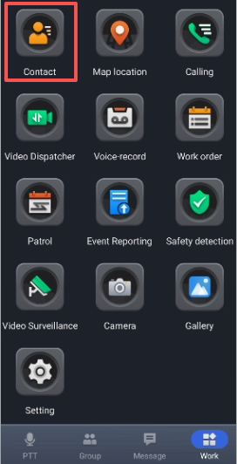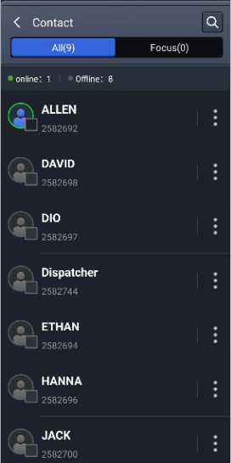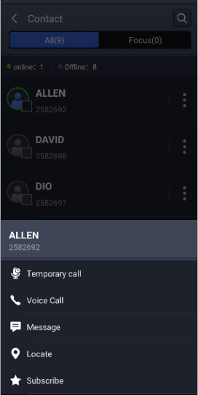
Figure 3-10 Contact

3.6.2 Locate Service
The locate service supports viewing the user's device location information. The interface allows users to choose to display the location of a single group or a specific user. Simultaneously, the locate interface integrates voice, messaging, and video functions for easy and quick operation, as shown in Figure 3-11.
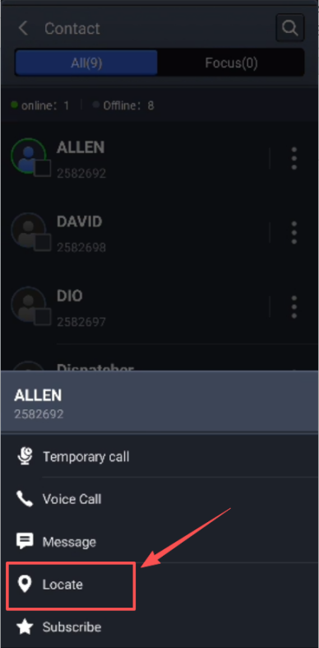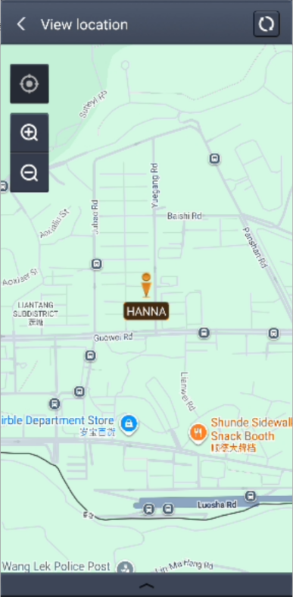
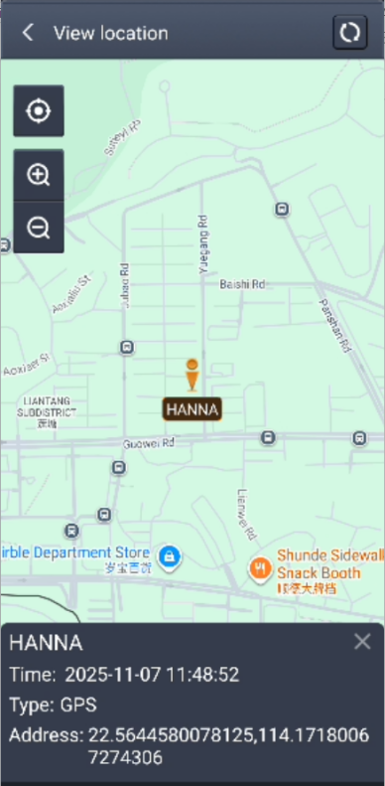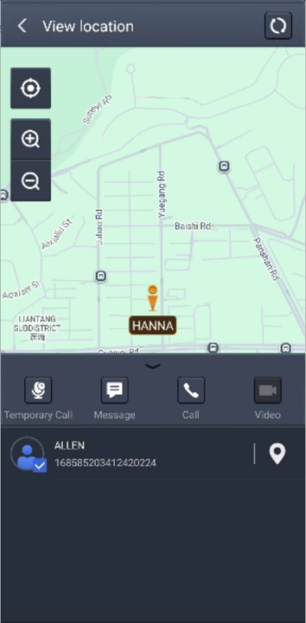
Figure 3-11 Map Positioning

3.6.3 Calling
The calling function also allows user to view the device's call history, and user can also click to use the full-duplex phone function (full-duplex voice call and full-duplex video call), or click to use the dial function to contact other users using a virtual number, as shown in Figure 3-12 below:
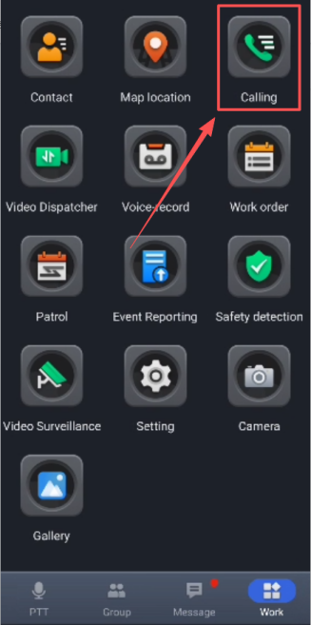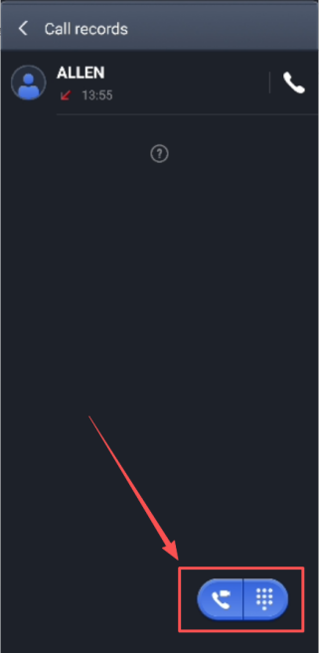
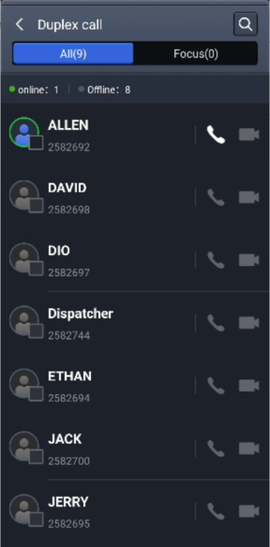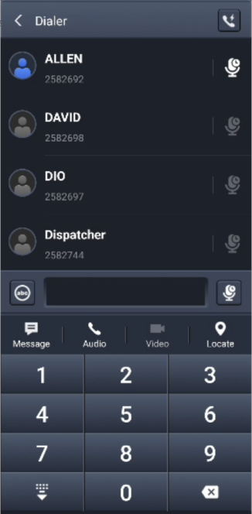
Figure 3-12 Calling

3.6.4 Video Return
The device supports video transmission. With a single click, the on-site video feed from the device can be uploaded to the dispatch console. During the video transmission process, screen recording or screenshots can be performed. It also supports switching between front and rear cameras to adapt to different scenario requirements, as shown in Figure 3-13 below:
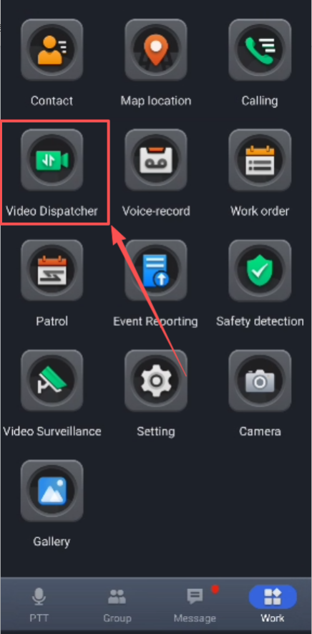
Figure 3-13 Video Transmission

3.6.5 Call Recording
The call recording function module includes previous call records for group call. Clicking on the corresponding group will allow you to play the previous voice recording, as shown in Figure 3-14 below:
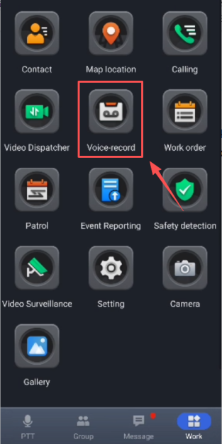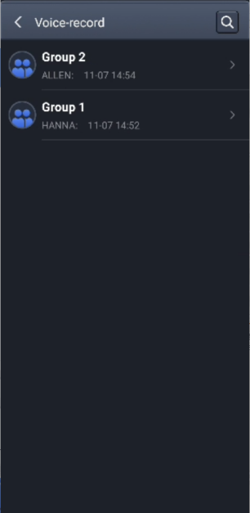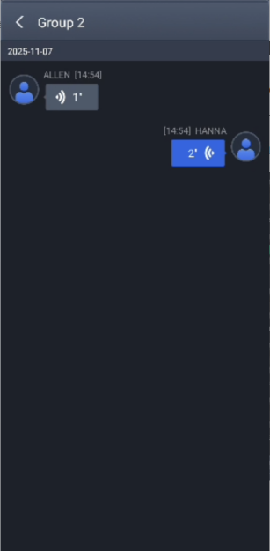
Figure 3-14 Call Recording

3.6.6 Work Order
After receiving a work order, the user can click to view the work order details. Then, based on the actual situation, the user can choose to "Carry Out" or "Refuse" the work order, as shown in Figure 3-15 below.
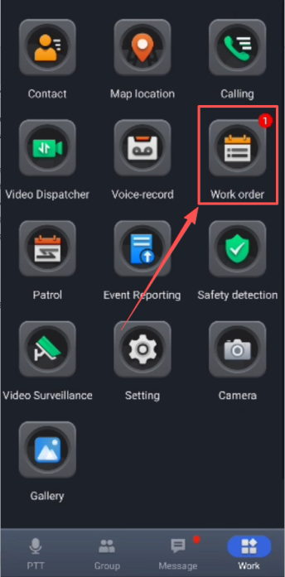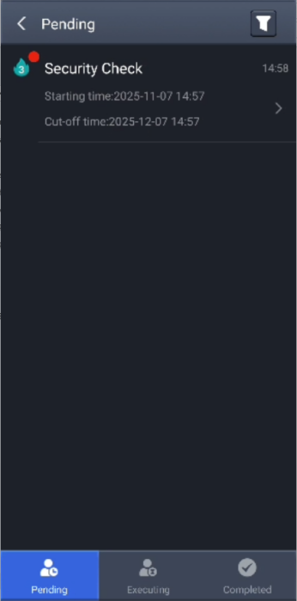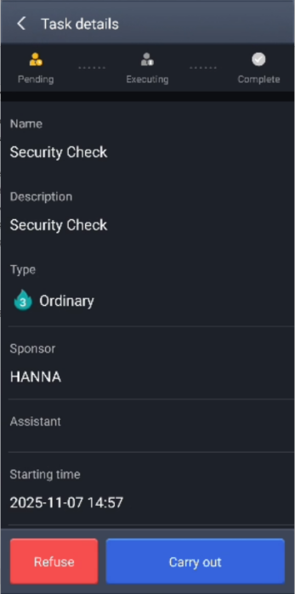
Figure 3-15 Work Order

If the user selects to refuse the work order, they can find the corresponding work order in "Carry out" during the task execution process. They can fill in the relevant information truthfully and add images or videos before submission. After submission and dispatcher approval, details can be viewed in the "Completed" work orders, as shown in Figure 3-16 below:
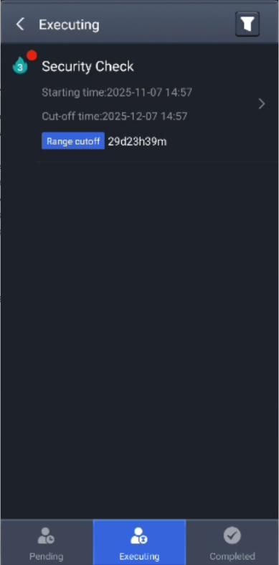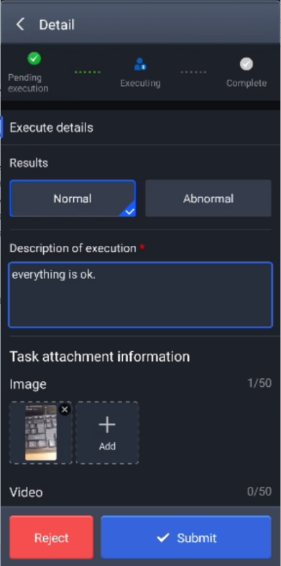
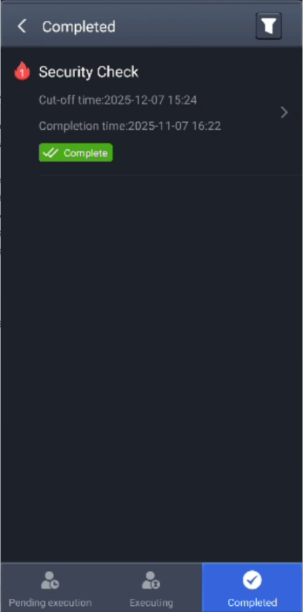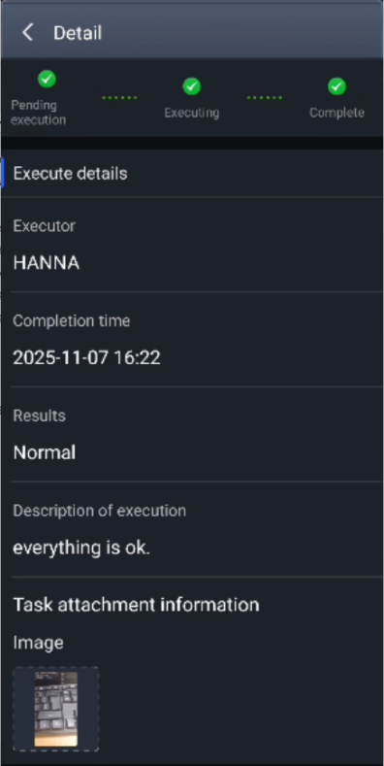
Figure 3-16 Execution Work Order

3.6.7 Patrol
Users can browse patrol plans published by the dispatch console in this module, and view their type (GPS or NFC) and execution status. After clicking to enter the corresponding patrol plan, the patrol points can be viewed, and the check-in can be directly confirmed after completion, as shown in Figure 3-17 below.
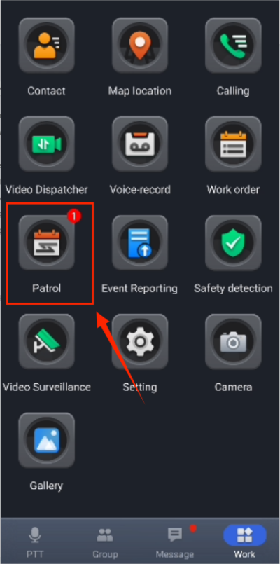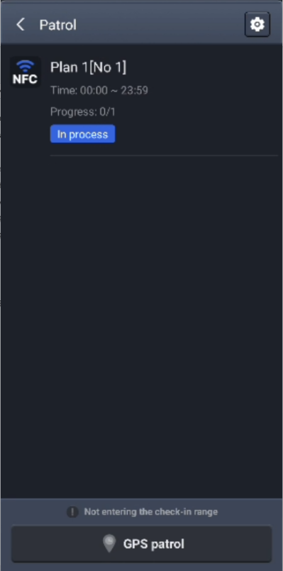
Figure 3-17 Patrol

3.6.8 Event Reporting
During patrols, if the device detects any anomalies in its jurisdiction, it can report the situation to the dispatch console via the event reporting module. The device fills in relevant information based on the situation and can also import additional images or videos to help the dispatcher better understand the situation. Users can also add event drafts and view historical events reported to the dispatch console, as shown in Figure 3-18 below.
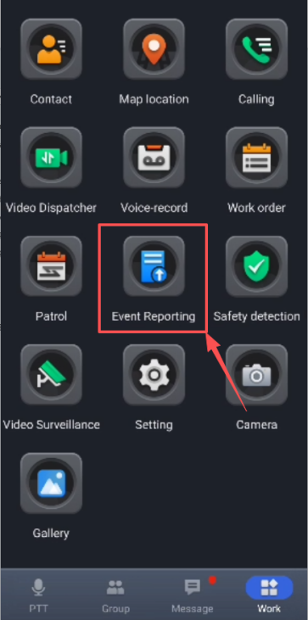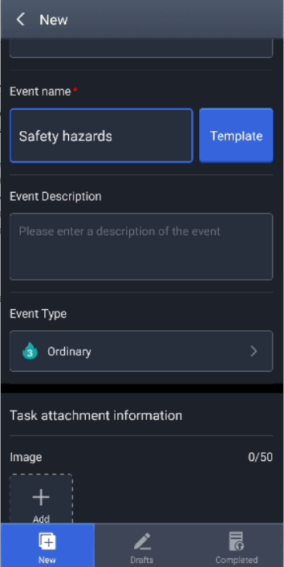
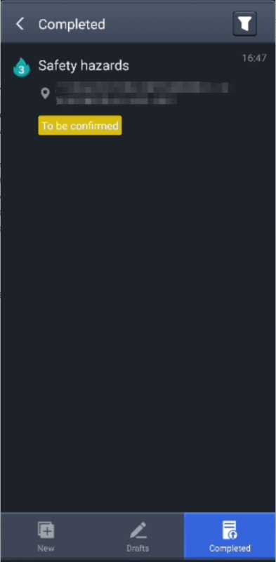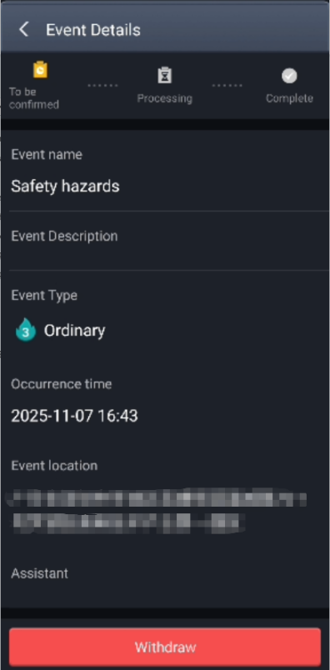
Figure 3-18 Incident Reporting

3.6.9 Safety Inspection
Zhongrui Technology APP client provides three safety detection functions: fall alarm, independent worker alarm, and stationary alarm. After clicking to enter the safety detection function, you will see the following as shown in Figure 3-19 :
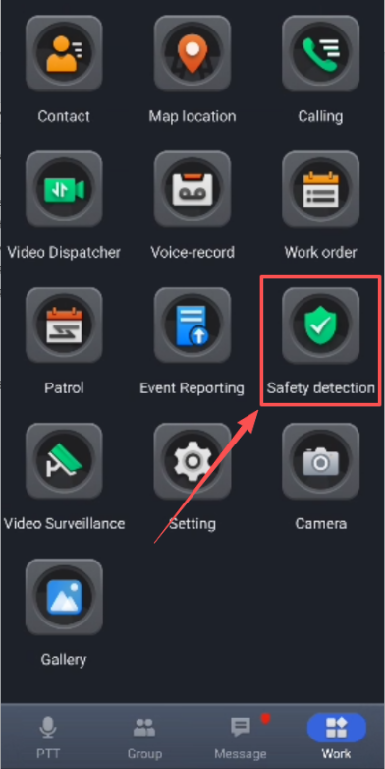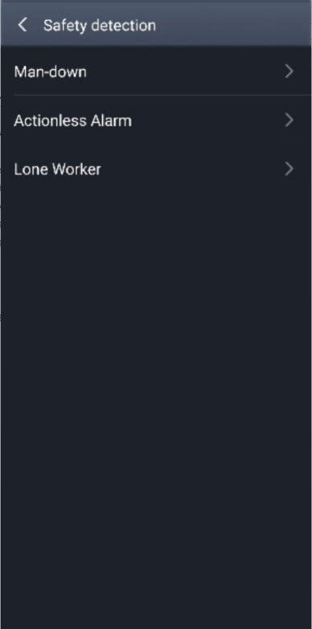
Figure 3-19 Safety Inspection

Man-down Alarm
Enable the man-down alarm setting. When the device falls to the ground for some reason, it will automatically send SOS alarm to the dispatch console, so that the dispatch console can understand the device's situation and promptly dispatch other users around the POC user for rescue.
After enabling the man-down alarm, the default settings details interface is shown in Figure 3-20 below . Users can modify the settings as needed or use the default settings directly.
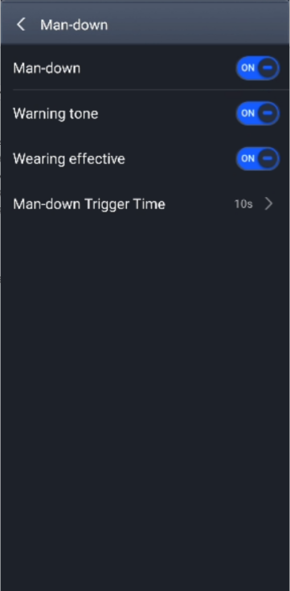
Figure 3-20 Man-down Alarm Settings

If the man-down alarm is triggered accidentally, user can cancel it by pressing the PTT button.

Actionless Alarm
After enabling the actionless alarm setting, the default settings details interface is shown in Figure 3-21 below .
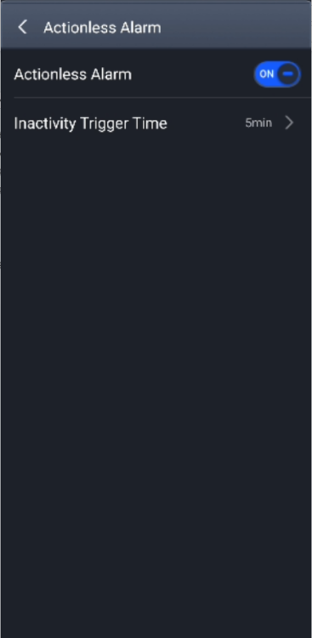
Figure 3-21 Actionless Alarm Settings

If the devices does not move within the specified time, the alarm will be triggered, and the dispatch console and current group members will be notified. The user can press the PTT button to cancel the alarm.

Lone Worker Alarm
For certain users that need to working alone, the lone worker alarm function can be enabled. The default settings details interface is shown in Figure 3-22 below .
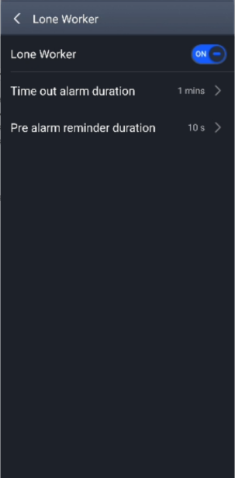
Figure 3-22 Lone Worker Alarm
If the device remains inactive within the "Time out alarm duration" this warning will be triggered. The user can cancel the alarm by pressing the PTT button within the " Pre alarm reminder duration". Otherwise, the dispatch console and current group users will automatically receive SOS alarm from the user. The SOS alarm diagram after triggering is shown in Figure 3-23 below :
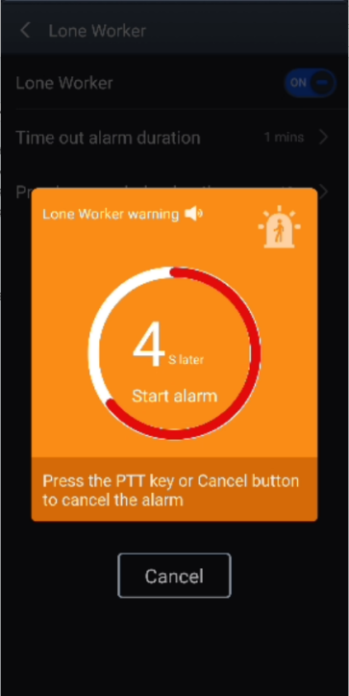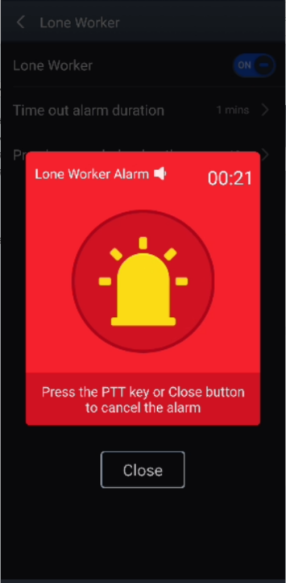
Figure 3-23 Alarm for Lone Worker

3.6.10 Video Surveillance
iConvNet converged dispatch platform supports the access of third-party cameras, such as Hikvision and Dahua cameras, which can be connected to the iConvNet platform via protocols such as GB28181, RTSP, ONVIF, etc. After the camera is connected to the platform, both the dispatch console and the device can view the camera footage, as shown in Figure 3-24 below:
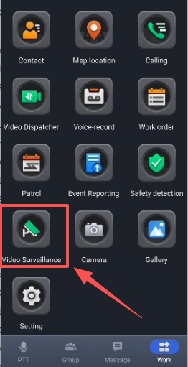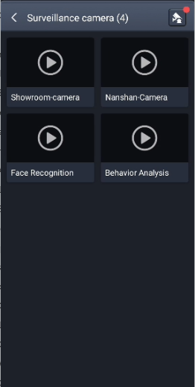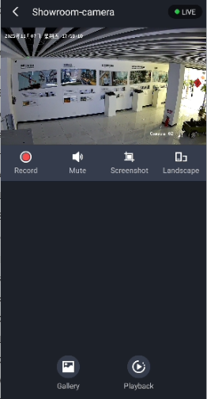
Figure 3-24 Camera Video Surveillance

iConvNet integrated dispatch platform has developed its own AI algorithm function and launched two access methods: AI and non-AI gateways. The iConvNet platform currently supports more than 60 algorithms. AI alarm information can also be pushed to the dispatch console and device through the gateway. The alarm information can be viewed on the device APP, as shown in Figure 3-25 below:
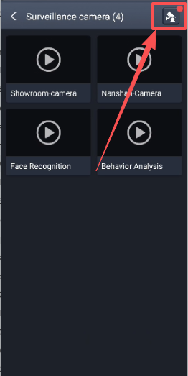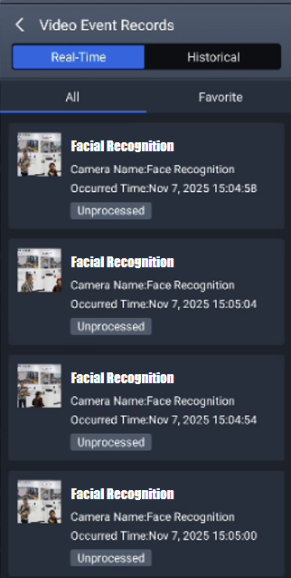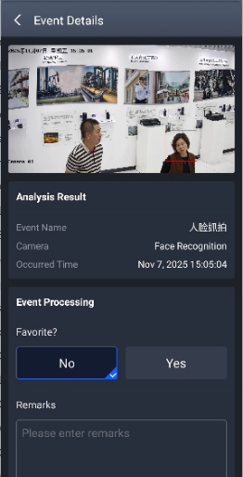
Figure 3-25 Video AI Events

3.6.11 Watermark Camera
iConvNet APP has a built-in watermark camera function, which supports photo and video modes to meet the photo needs in daily work, as shown in Figure 3-26 below:
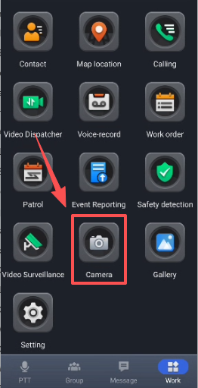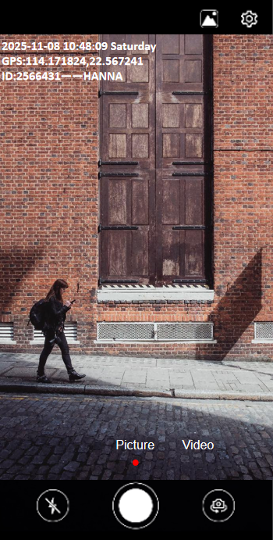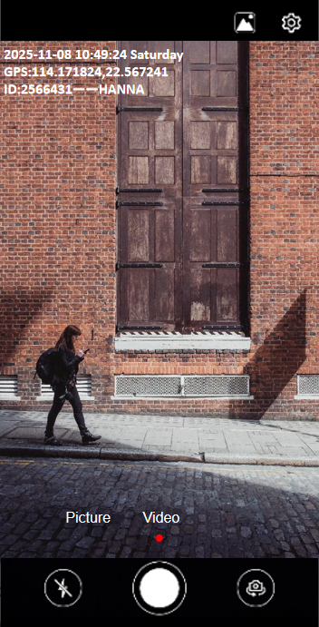
Figure 3-26 Watermark Camera

3.6.12 Gallery
iConvNet APP has a built-in gallery function. Clicking it allows you to view pictures and videos taken by the APP's built-in watermark camera, making management and viewing convenient, as shown in Figure 3-27 below:
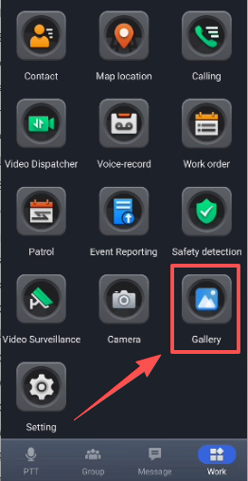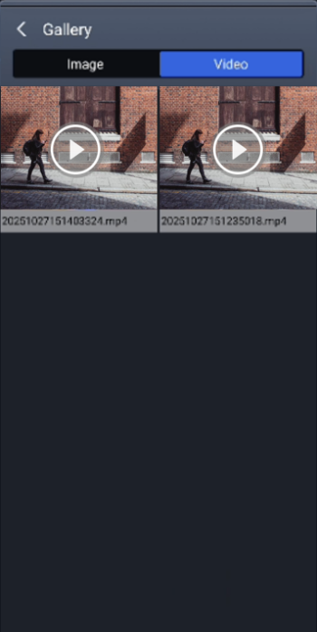
Figure 3-27 Gallery

3.7 Voice and Video
On the app's homepage, users can select group users and initiate calls, video calls, and other operations by long-pressing the username. As shown in Figure 3-28 below:
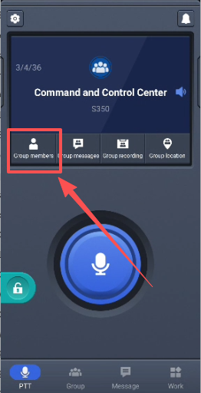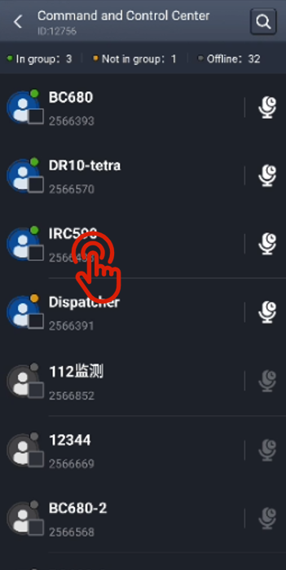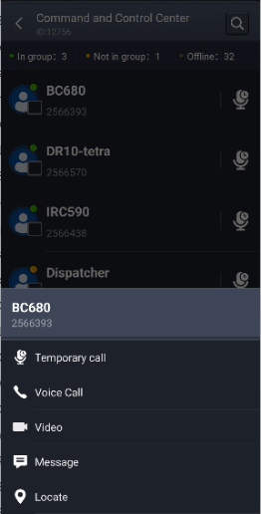
Figure 3-28 Voice and Video

3.8 Settings​
Click to enter the app settings to confirm app settings and view account information, as shown in Figure 3-29 below :
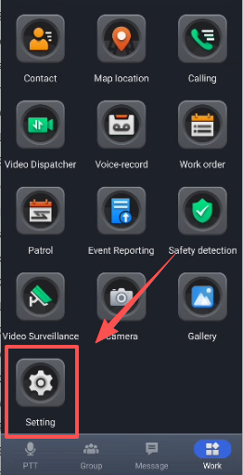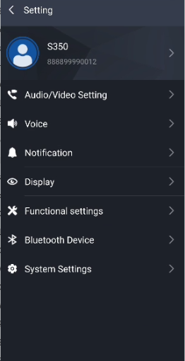
Figure 3-29 Settings

3.8.1 Basic Account Information
Clicking the account information bar will take you to the basic account information interface, where you can view basic information such as account ID and name. You can also customize your account avatar, name, and password, as shown in Figure 3-30 below:
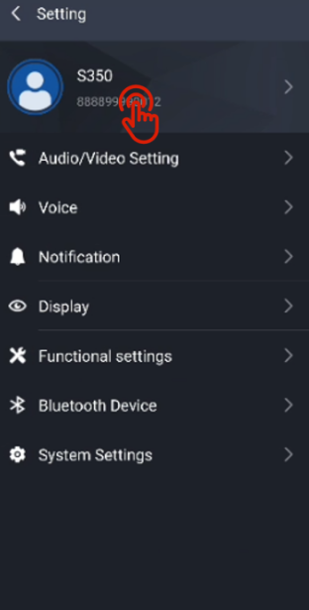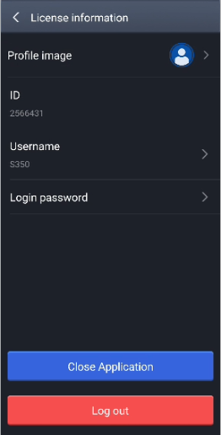
Figure 3-30 Account Basic Information

3.8.2 Audio/Video Settings
In this feature, users can configure video-related settings in the iConvNet app, switch between the default front/rear camera, and adjust parameters such as video resolution, frame rate, and bitrate, as shown in Figure 3-31 below:
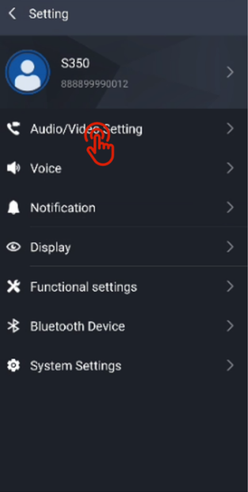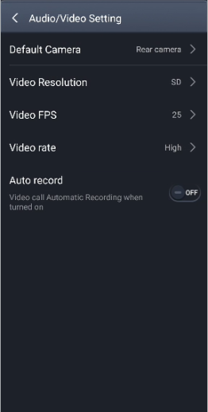
Figure 3-31 Audio and Video Settings

3.8.3 Voice​​
In this feature, users can configure whether certain functions should have intercom prompts enabled, as well as group name broadcasting and message notification modes. For example , as shown in Figure 3-32 , when " PTT Start " is enabled, a prompt tone will play when the user presses the PTT button to start an intercom .
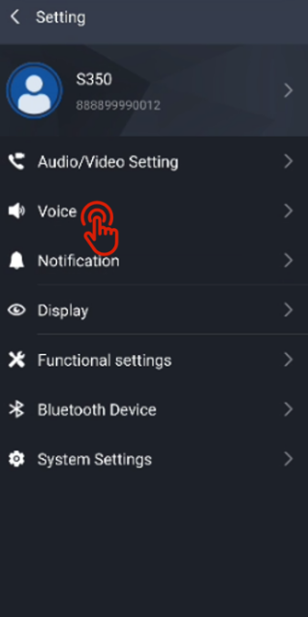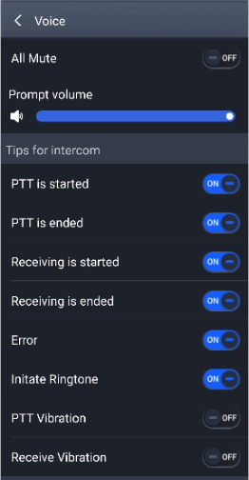
Figure 3-32 Voice Settings
3.8.4 Notification
In this module, users can configure whether to allow notifications when using APP functions and whether to light up the screen when notifications are received , as shown in Figure 3-33 below .
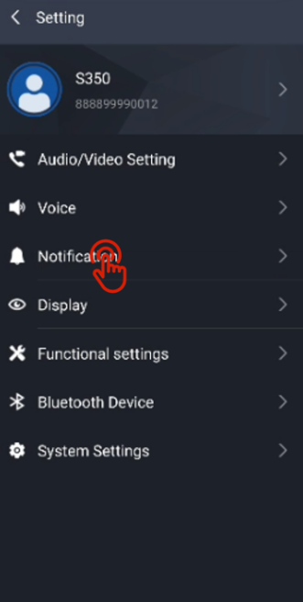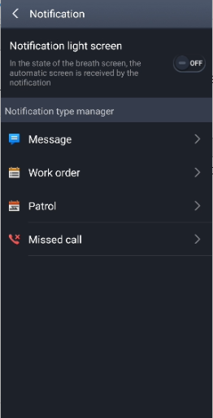
Figure 3-33 Notification settings

3.8.5 Display
In this module, users can set functions such as "lock screen", "wake up screen", "disable sleep", as well as settings such as "floating ball" and "SOS floating", as shown in Figure 3-34 below .
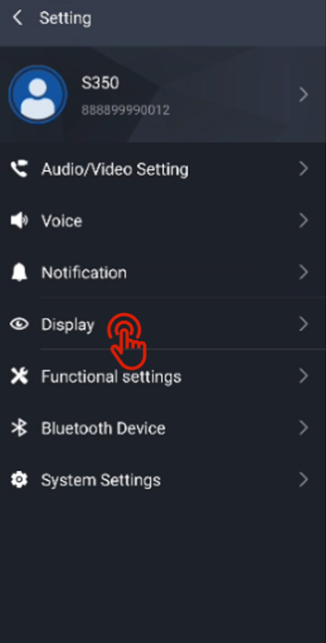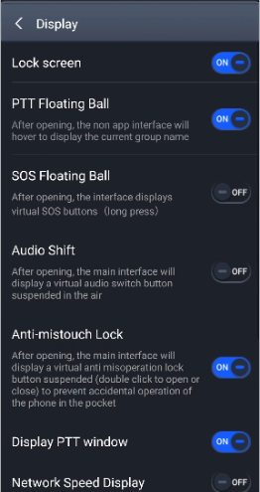
Figure 3-34 Function Settings

3.8.6 Functional settings
In this module, users can set up automatic answering of calls, including "temporary calls," "voice calls," and "video calls." Users can also customize button operations for some functions, as shown in Figure 3-35 below.
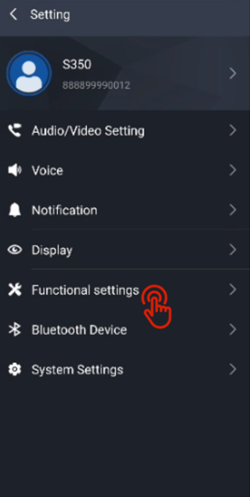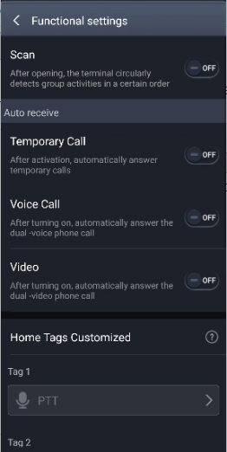
Figure 3-35 Function settings

3.8.7 Bluetooth Devices
In this module, users can enable Bluetooth to connect to Bluetooth devices, as shown in Figure 3-36 below.
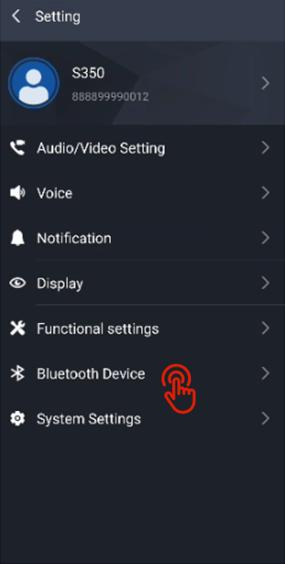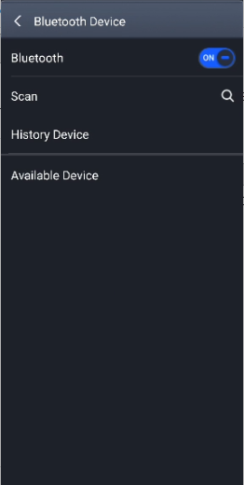
Figure 3-36 Bluetooth Device

3.8.8 System Settings
In this module, users can view information such as the app's version number and storage space in the " About " section, as shown in Figure 3-37 below .
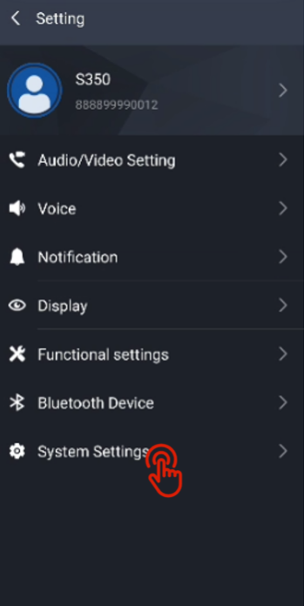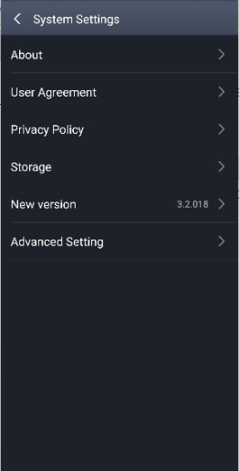
Figure 3-37 System Settings

Clicking " Advanced settings " will take you to the Android system settings page, as shown in Figure 3-38 .
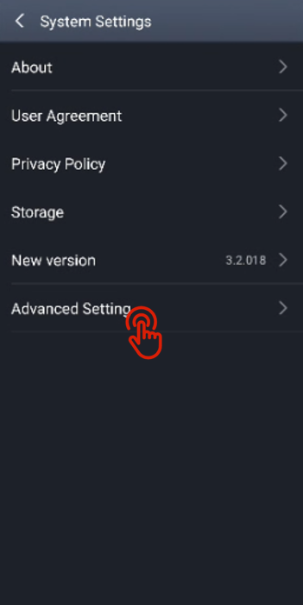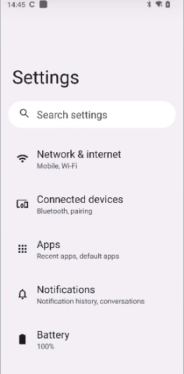
Figure 3-38 Android System Settings

3.8.8 Close Application and Log Out
In the settings menu, click User Information. Users can find the "Close Application" and "Log Out" options., as shown in Figure 3-39 below .
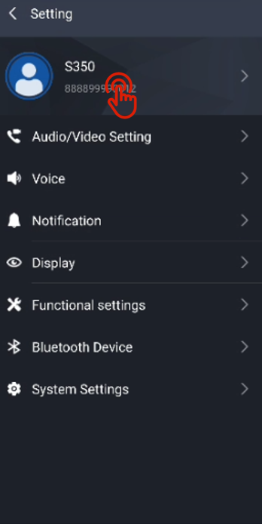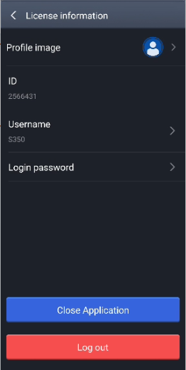
Figure 3-39 “Close Application” and “Log Out”

